Adam Mohmoud
AZ-900 Fundamentals
VM for Security Network Traffic Lab
Mohmoud.adam@gmail.com

In this lab, I will create a virtual machine and configure a network security group, configure an inbound and outbound security port rule to allow RDP.
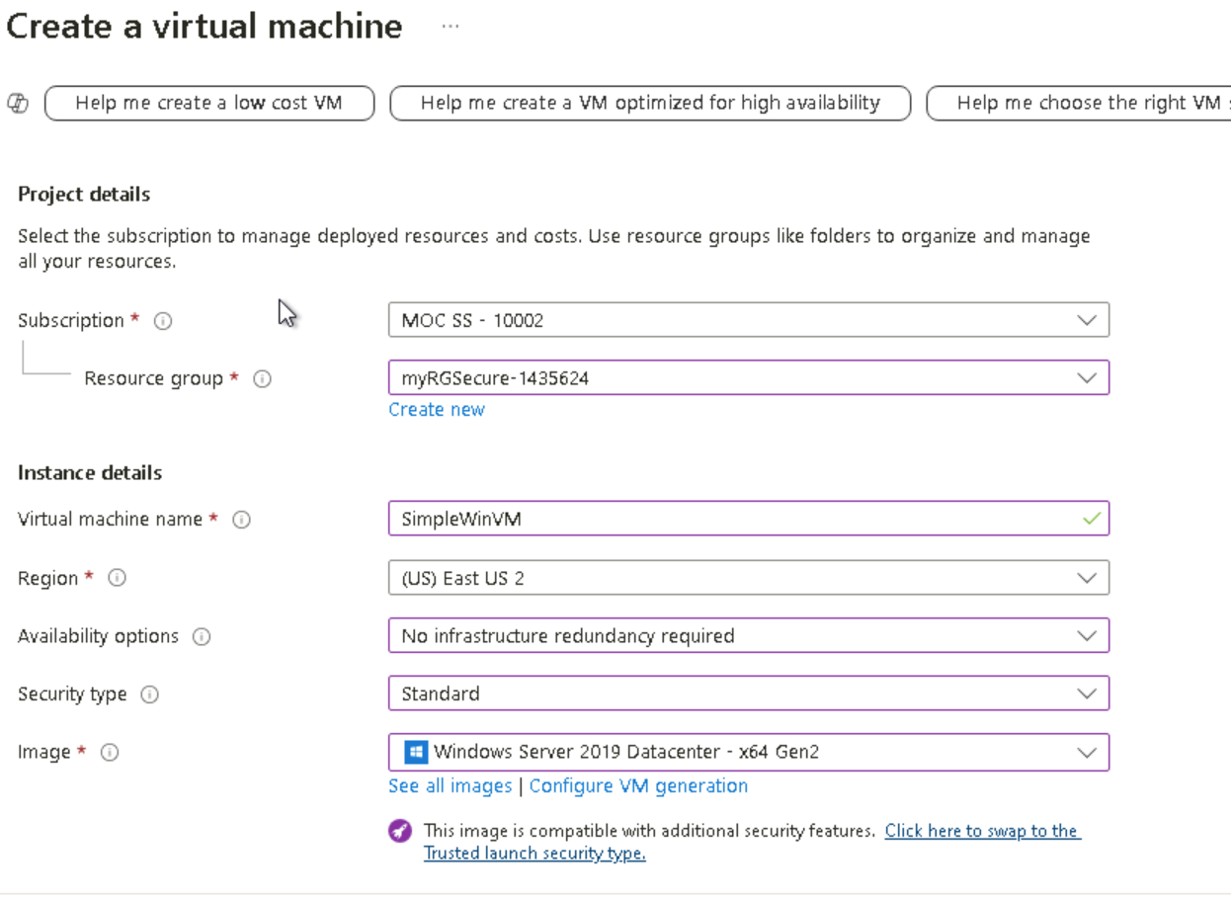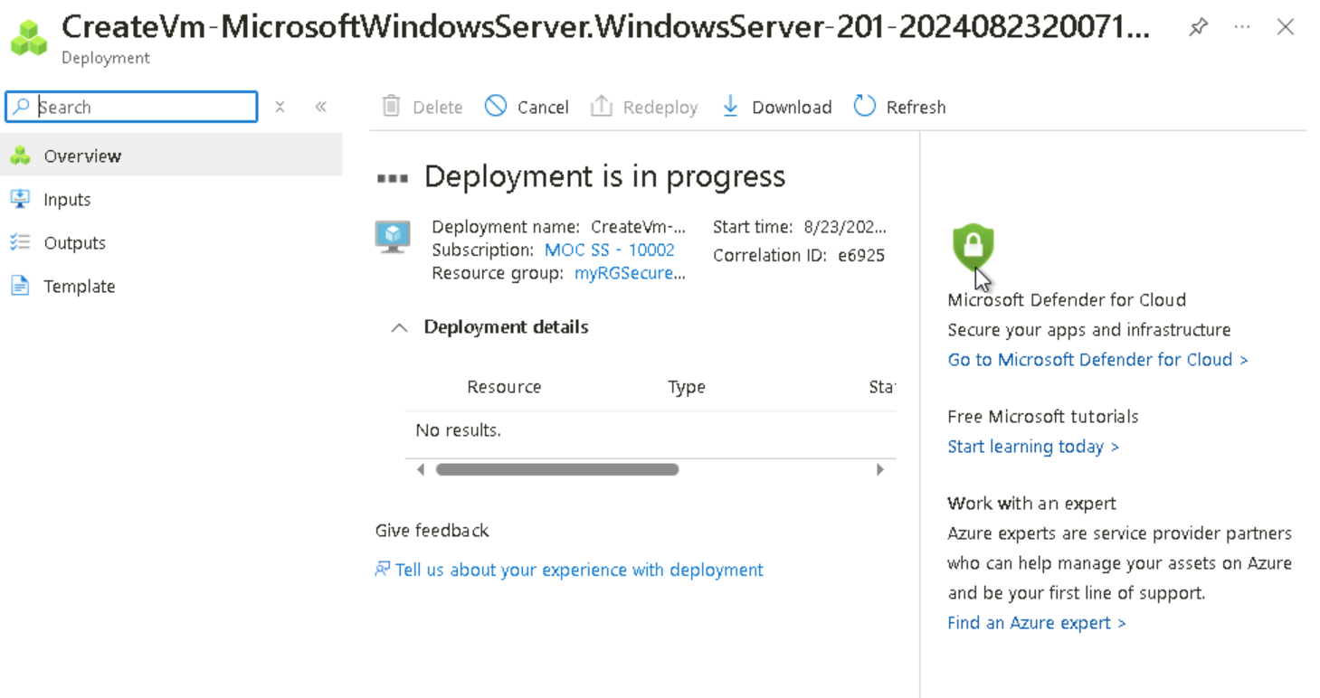
I am going to input the project details necessary for this lab and then deploy the virtual machine. I will create a network security group and associate it with the network interface.

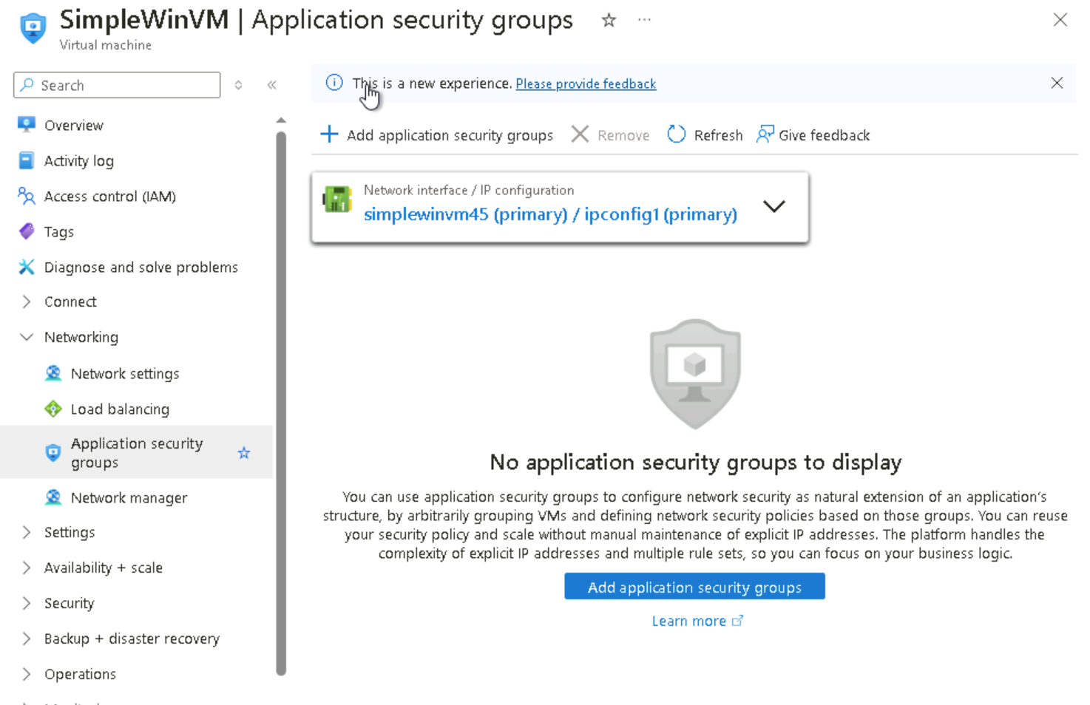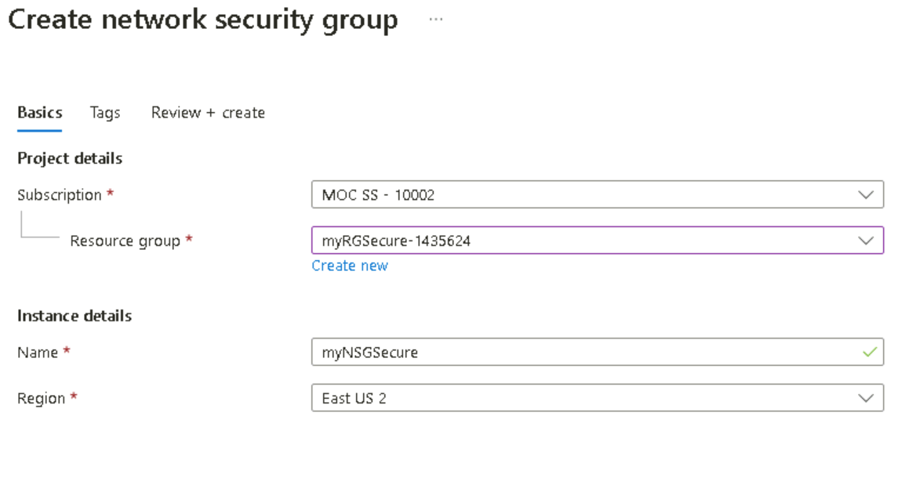
On the SimpleWinVM blade under ‘networking’, I want to confirm that there is no network security group associated with the network interface of the virtual machine or the subnet to which the network interface is attached.
From the Search resources, services, and docs blade, search for and select Network security groups and then click ‘+ Create’ to create a network security group.

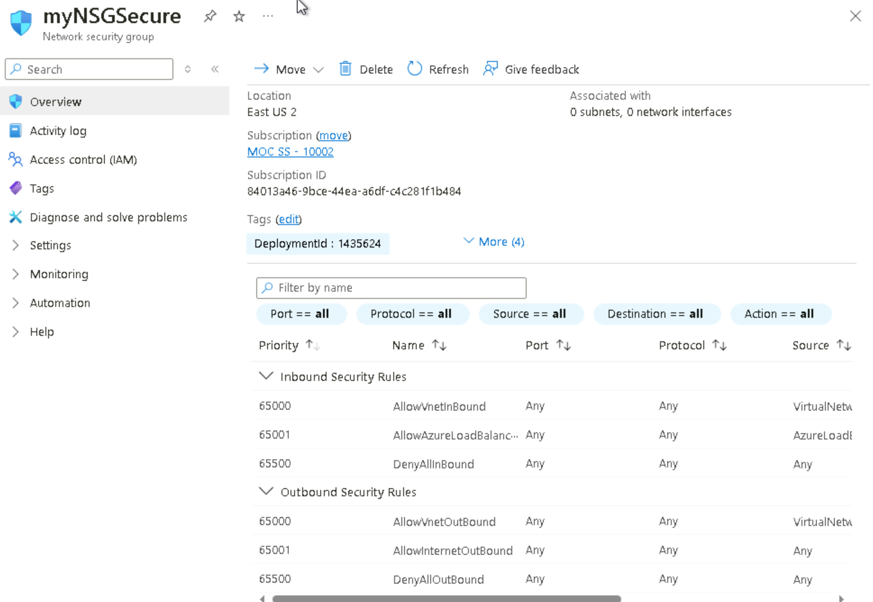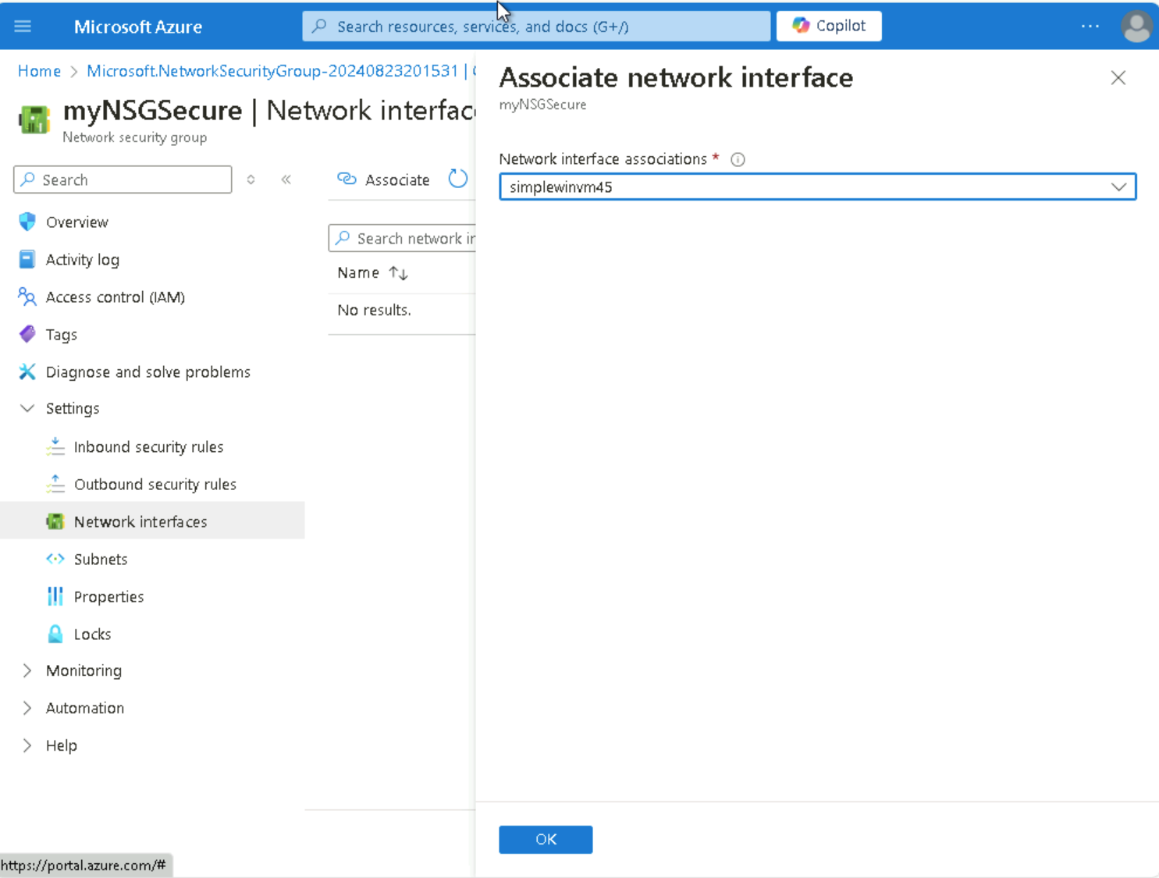
After creating the group, under ‘settings’, I will click Network Interfaces followed by Associates. I will select the network interface that I had identified previously.

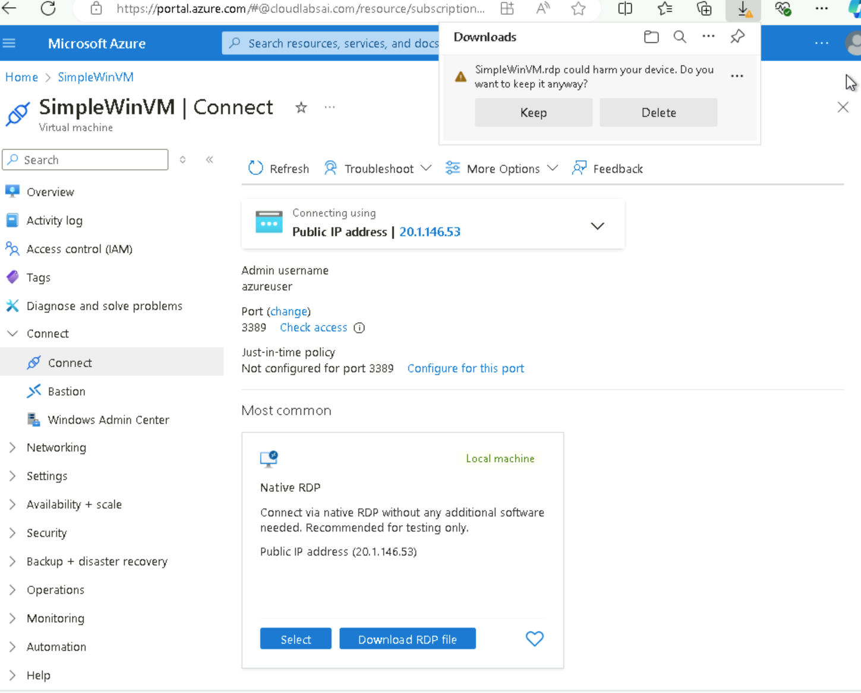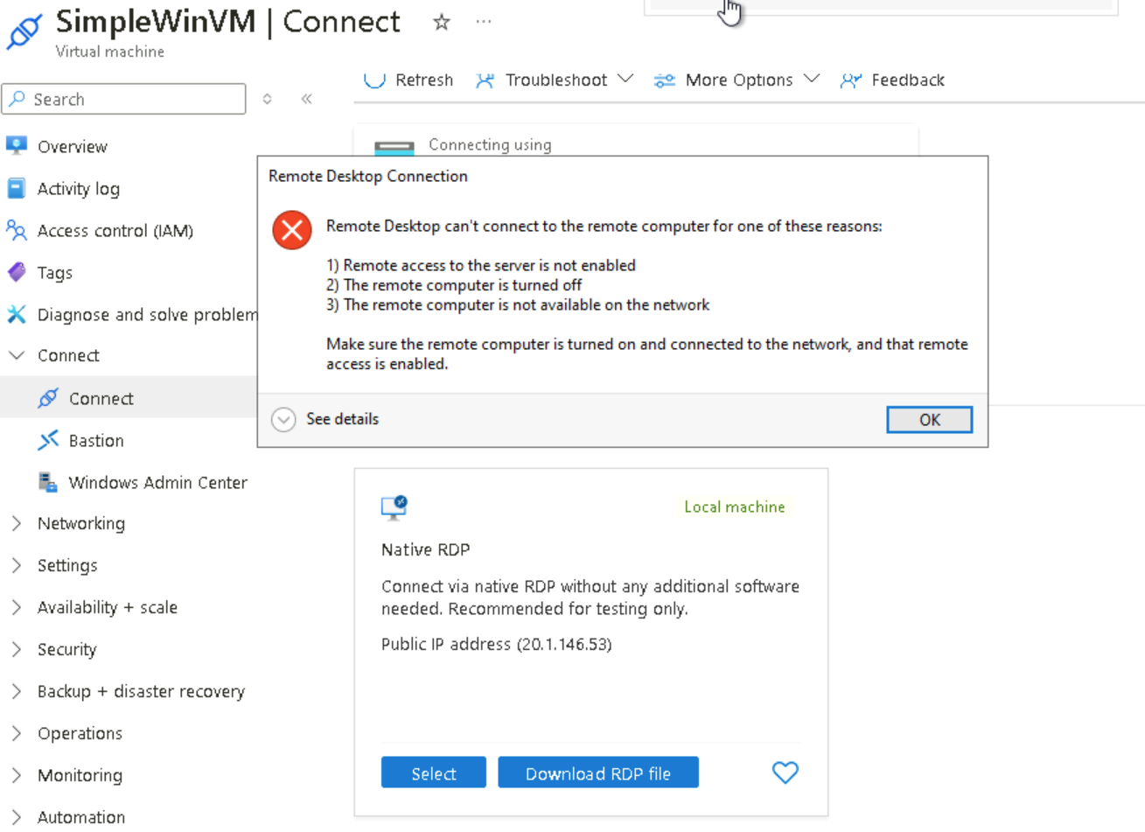
I will allow RDP traffic to the virtual machine by configuring an inbound security port rule. On the SimpleWinVM, I will connect the page, under native RDP, click on Download RDP file. I will attempt to connect the virtual machine using RDP. By default the network security group does not allow the RDP as displayed in the error that appears.

On the virtual machine blade, under ‘Settings’, then ‘Networking’, I clicked the inbound rules for the myNSGSecure (attached to network interface: simplewinvm) network security group to deny all inbound traffic except traffic within the virtual network and load balancer probes.
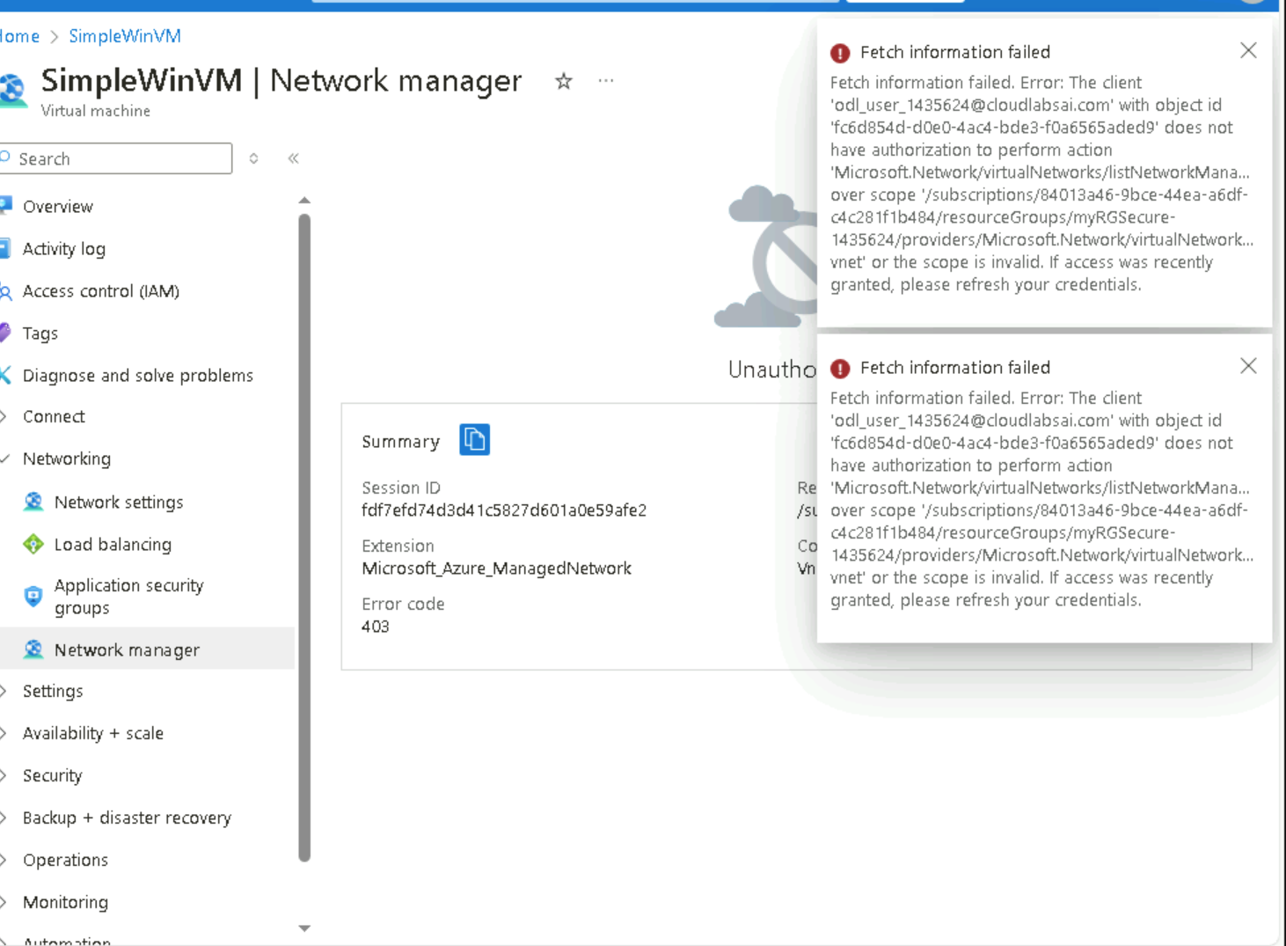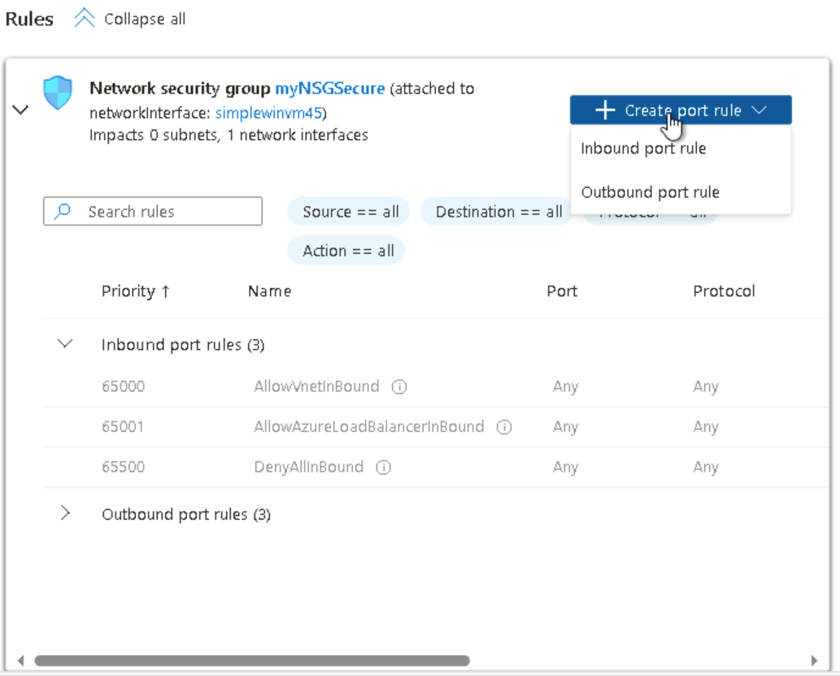
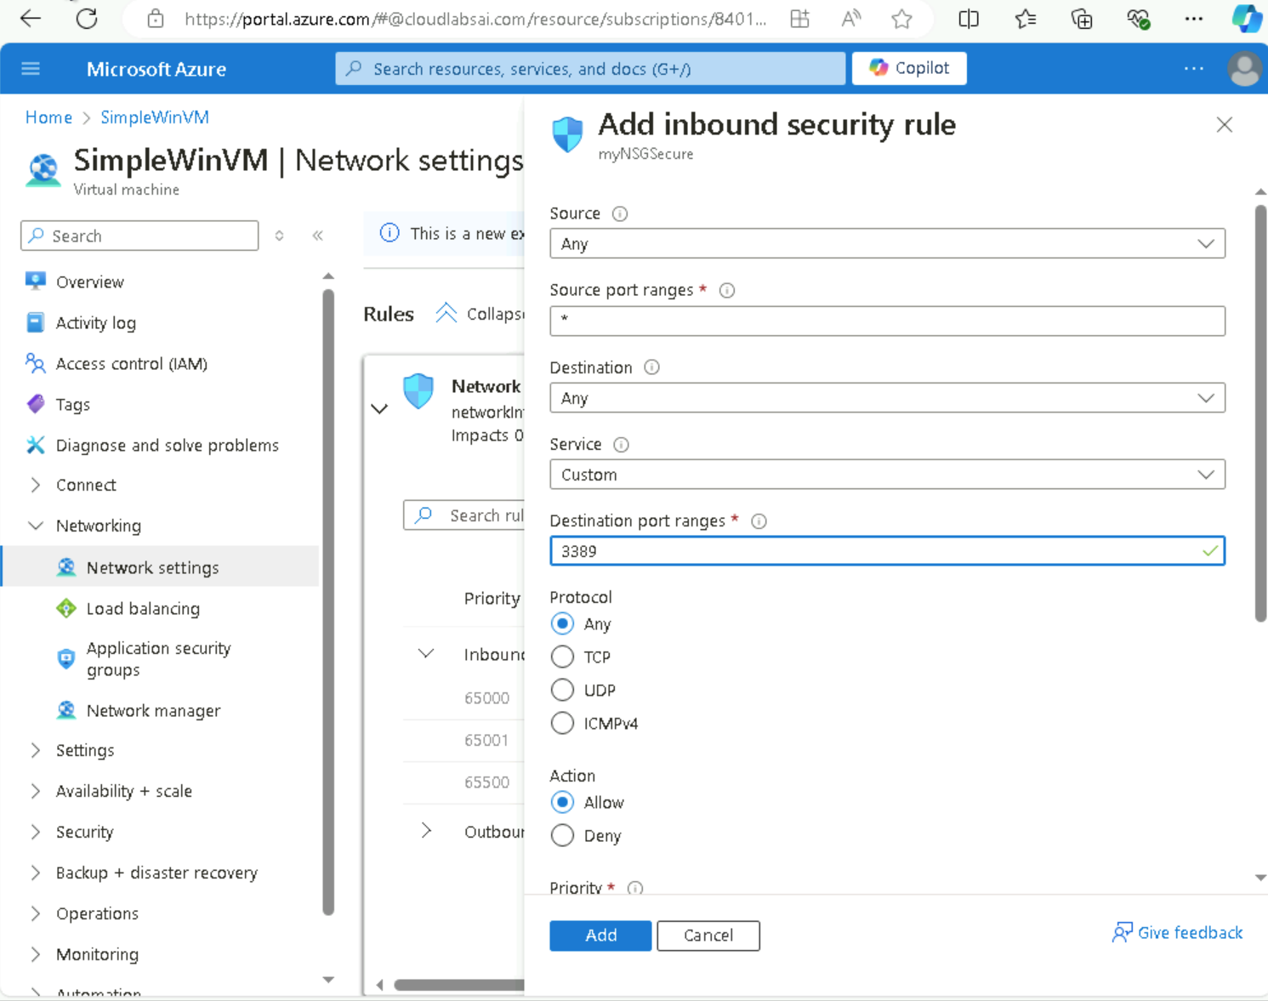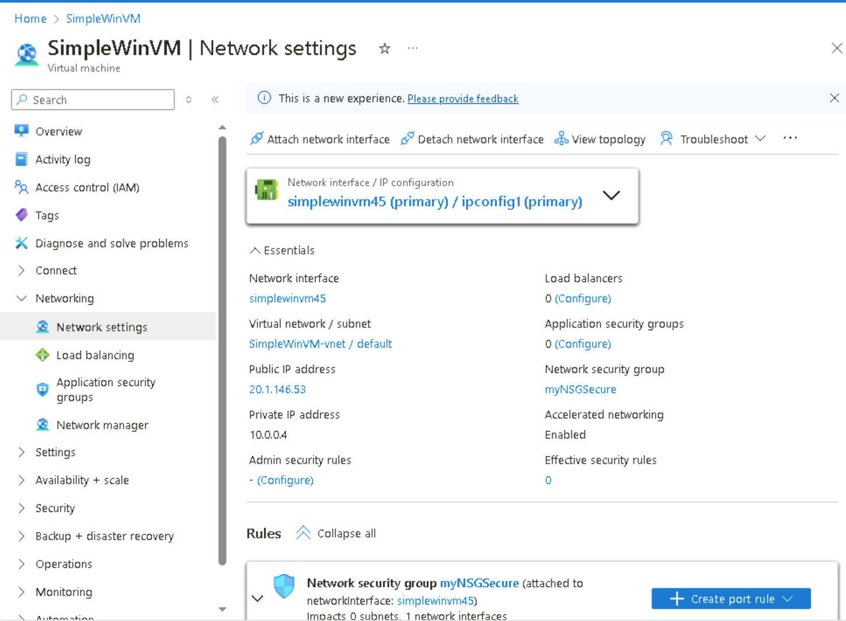

I proceeded with ‘+ Create port rule’ Inbound port rule and provided the values to the respective settings and added them. After the rule was provisioned I again, tried the RDP into the virtual machine using downloaded RDP file and it was successful.

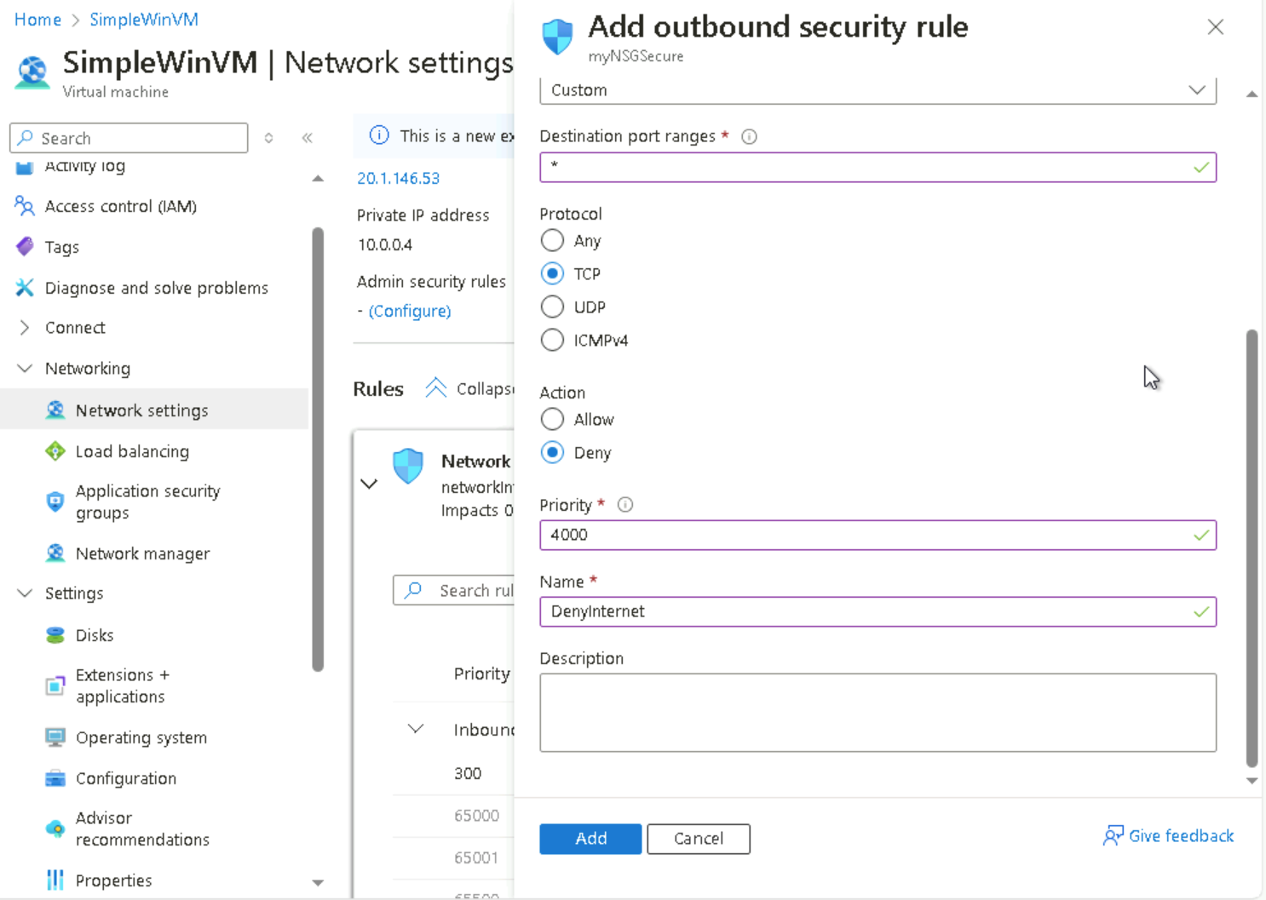
In this task, I will continue with the outbound port rule that will deny Internet access and then test to ensure the rule is working. Entering the values for the settings and provisioned them.

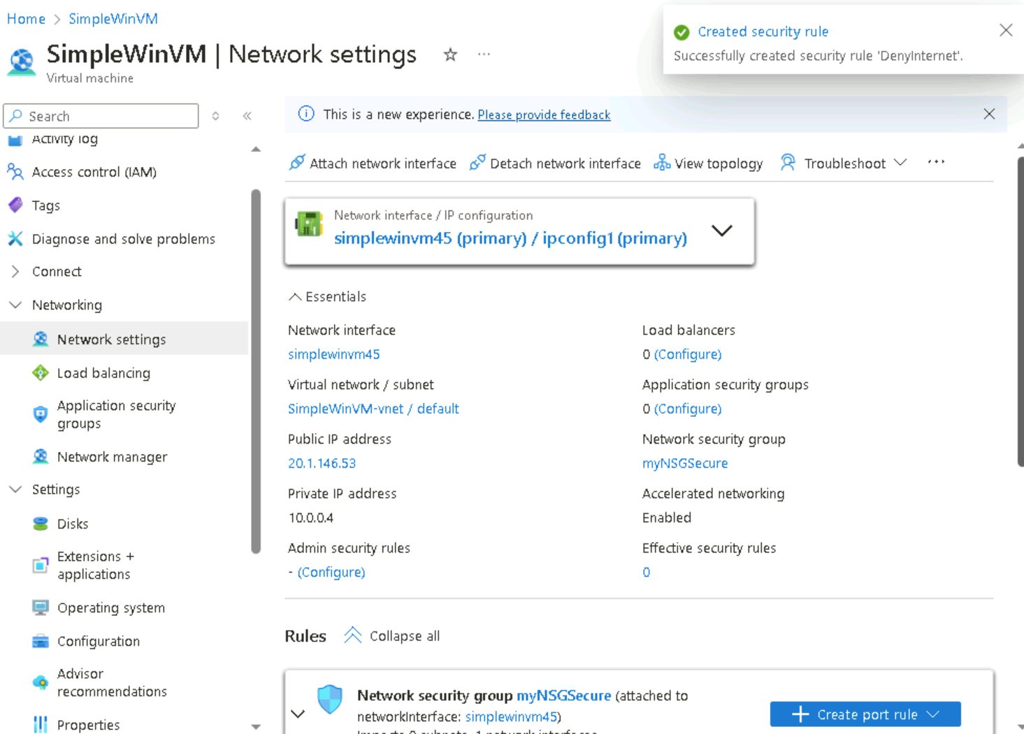

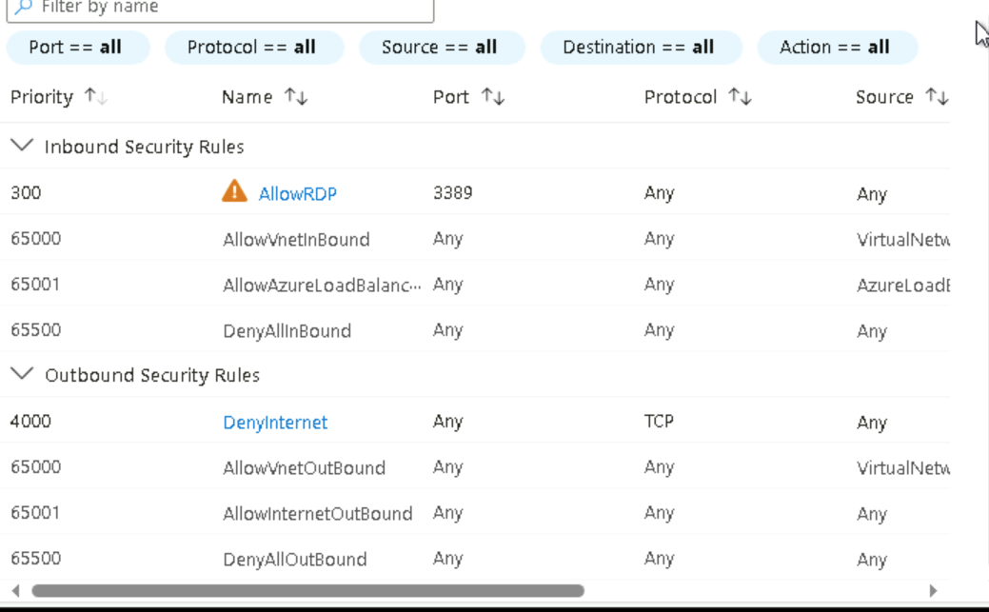
After submitting the out bound portal rule, I access the RDP. Through the VM machine I opened a search engine for www.bing.com and discovered that the page does not display due to the security rules set.
